**Step 1: Load the Dataset**

Dataset Overview:

<class 'pandas.core.frame.DataFrame'>

RangeIndex: 8708 entries, 0 to 8707

Data columns (total 11 columns):

 #   Column      Non-Null Count  Dtype

---  ------      --------------  -----

 0   id          8708 non-null   int64

 1   timestamp   8708 non-null   object

 2   season      8708 non-null   object

 3   holiday     8708 non-null   object

 4   workingday  8708 non-null   object

 5   weather     8708 non-null   object

 6   temp        7506 non-null   float64

 7   temp_feel   8606 non-null   float64

 8   humidity    8669 non-null   float64

 9   windspeed   8508 non-null   float64

 10  demand      8708 non-null   float64

dtypes: float64(5), int64(1), object(5)

memory usage: 748.5+ KB

None

Descriptive Statistics:

                id         temp  ...    windspeed       demand

count  8708.000000  7506.000000  ...  8508.000000  8708.000000

mean   4354.500000    20.089454  ...    13.048589     4.452722

std    2513.927405     8.023304  ...     8.311058     1.493966

min       1.000000     0.820000  ...     0.000000     0.000000

25%    2177.750000    13.940000  ...     7.001500     3.637600

50%    4354.500000    20.500000  ...    12.998000     4.867500

75%    6531.250000    26.240000  ...    19.001200     5.556800

max    8708.000000    41.000000  ...    56.996900     6.792300

[8 rows x 6 columns]

First Few Rows:

   id         timestamp  season holiday  ... temp_feel humidity  windspeed  demand

0   1  01-01-2017 00:00  spring      No  ...    14.395     81.0        0.0  2.7726

1   2  01-01-2017 01:00  spring      No  ...    13.635     80.0        0.0  3.6889

2   3  01-01-2017 02:00  spring      No  ...    13.635     80.0        0.0  3.4657

3   4  01-01-2017 03:00  spring      No  ...    14.395     75.0        0.0  2.5649

4   5  01-01-2017 04:00  spring      No  ...    14.395     75.0        0.0  0.0000

[5 rows x 11 columns]

**Step 2: Univariate Analysis**

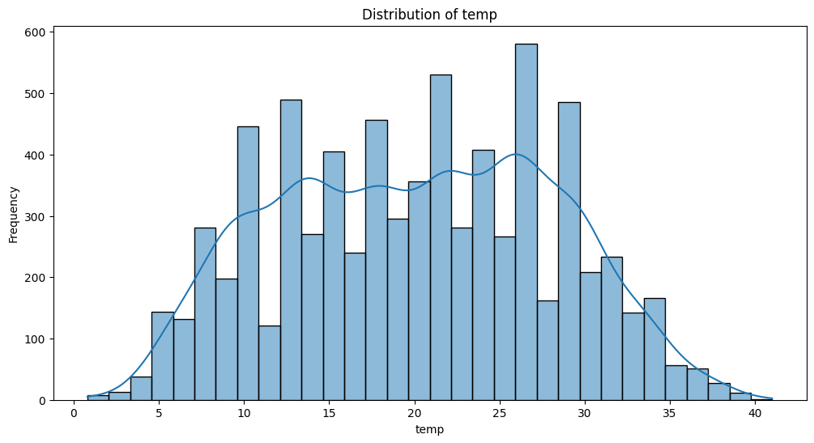

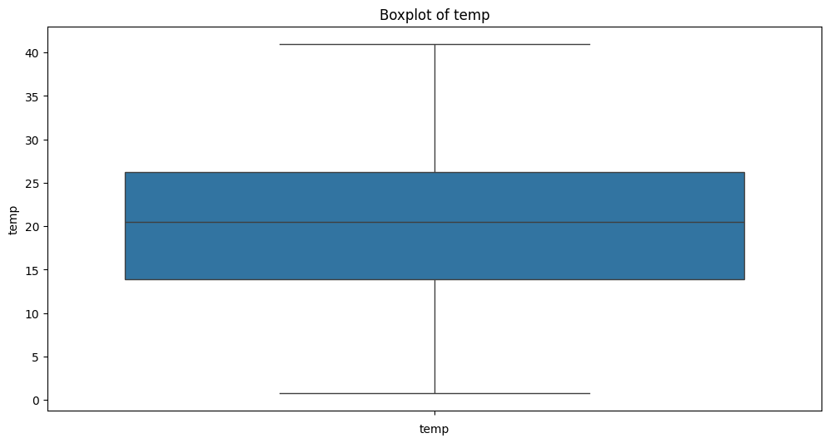

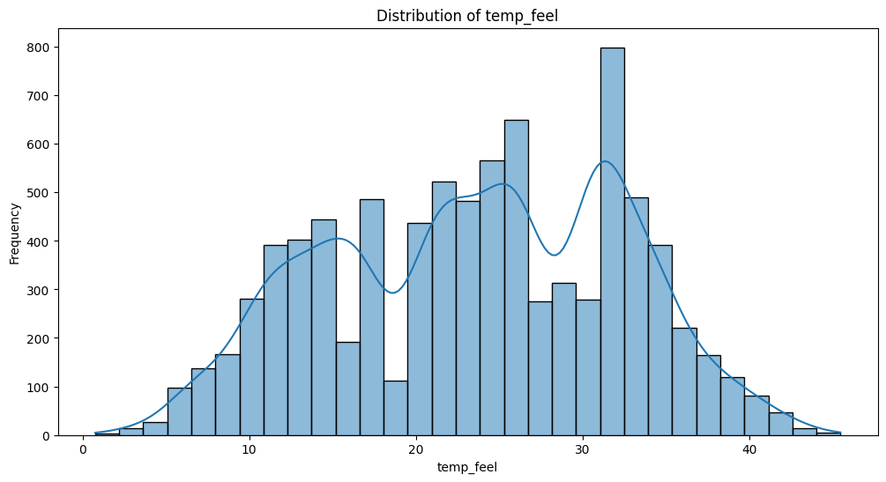

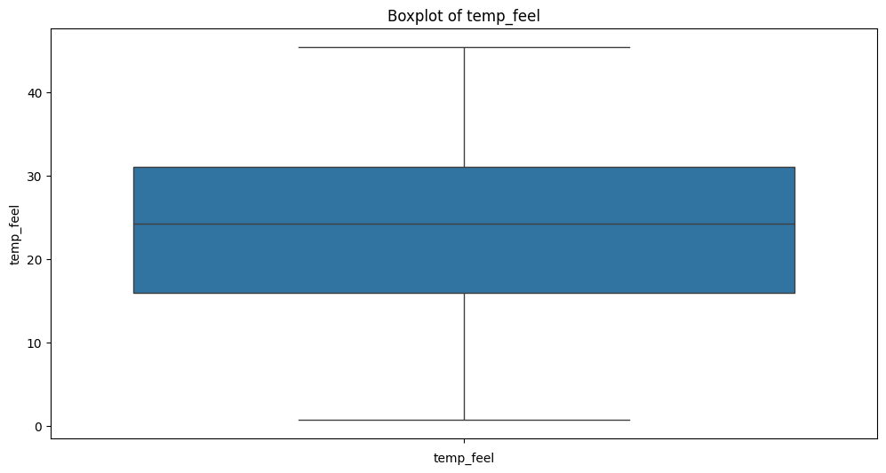

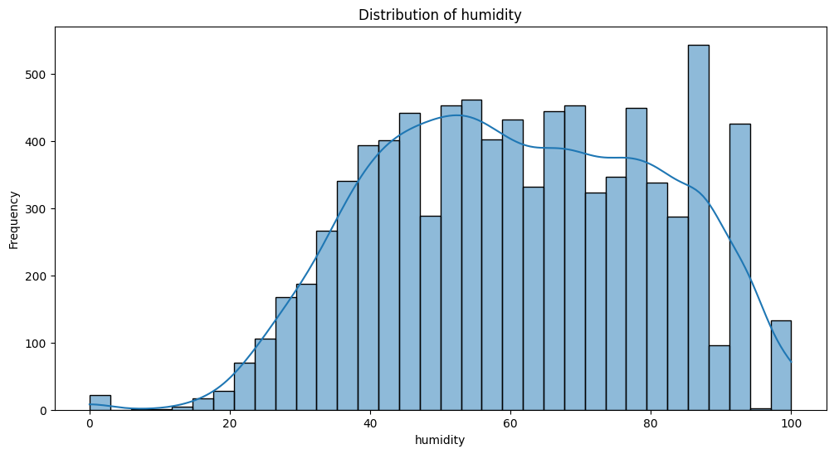

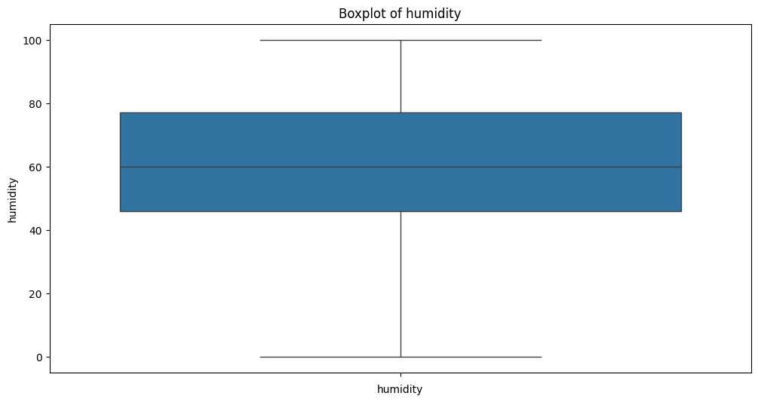

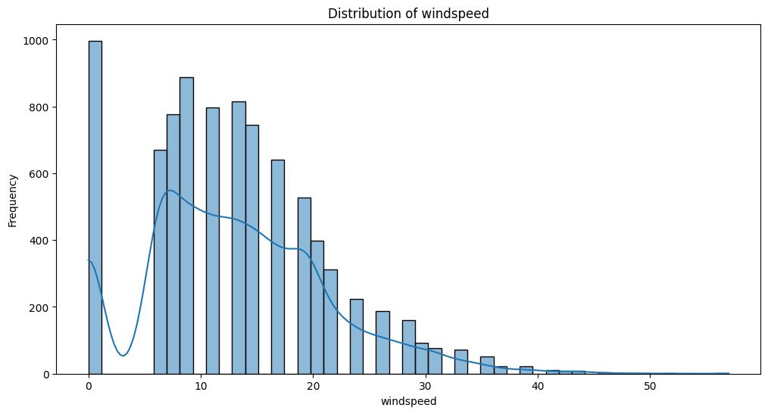

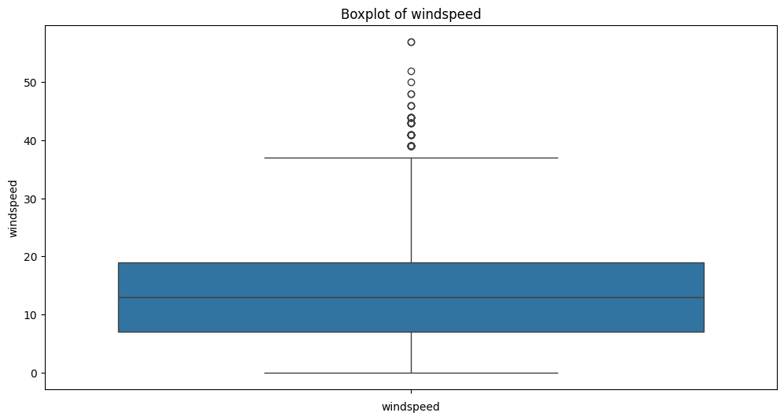

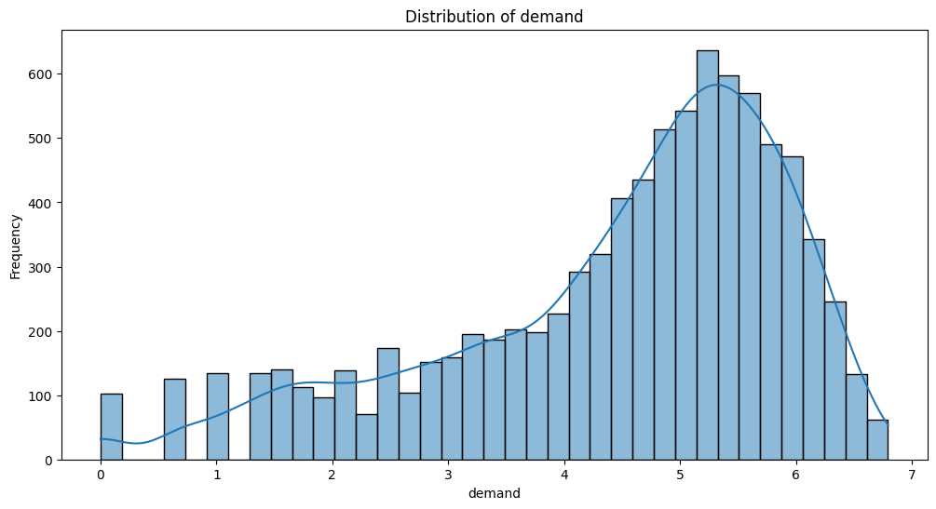

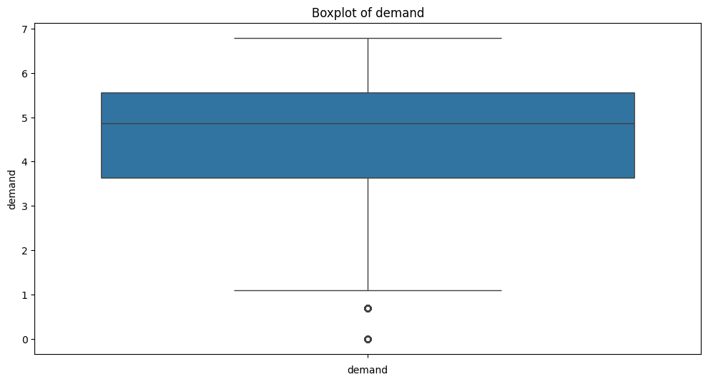

**Step 3: Correlation Analysis**

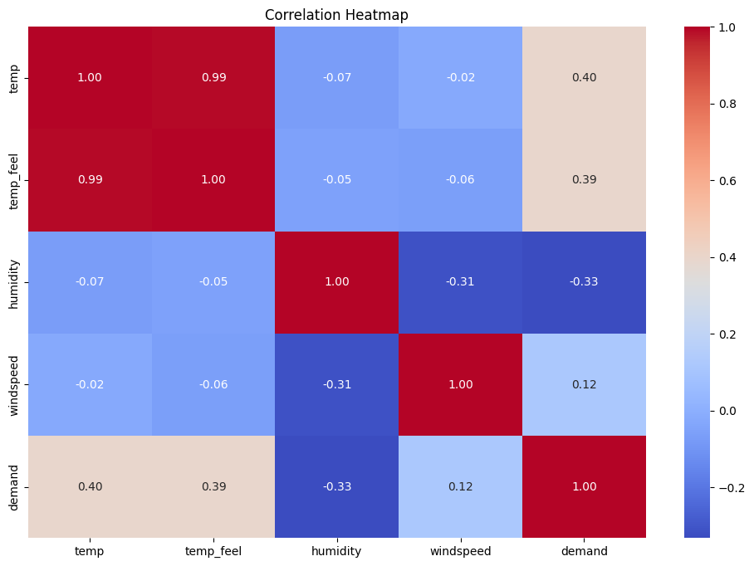

Correlation with Demand:

demand       1.000000

temp         0.396124

temp_feel    0.392632

windspeed    0.119635

humidity    -0.331555

Name: demand, dtype: float64

#### Step 4: Feature Importance and Visualization

#### 

#### 

#### 